DAD – Tasks – < specify task > ( e.g. Access Lesson 2 )

Student ID: 103577332

Student Name: Ibrahim Oztas

## Task 1.

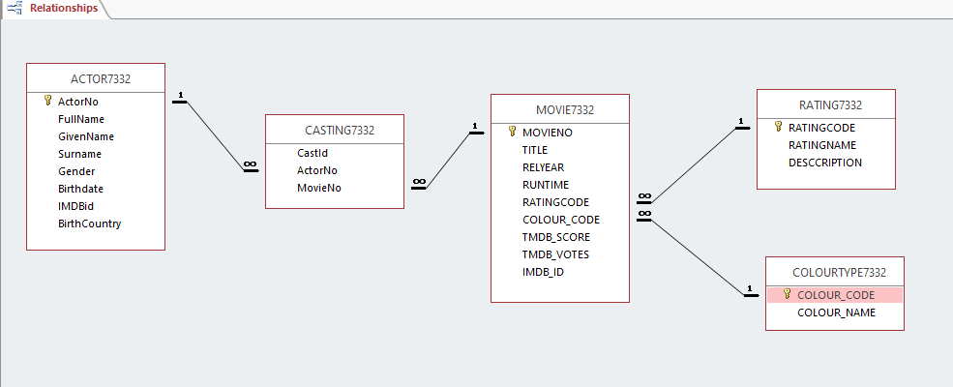

## Task 2

Paste your screen captures for this task here.

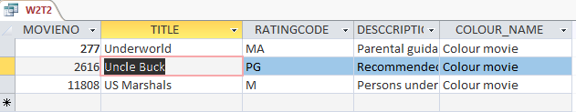

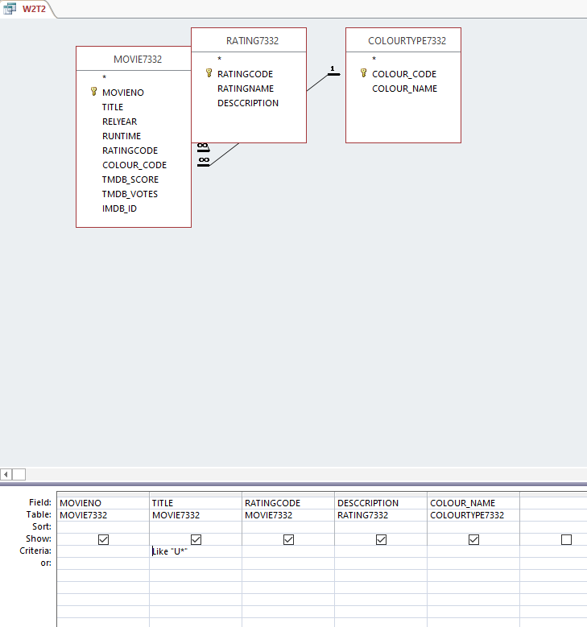

## Task 3

Paste your screen captures for this task here.

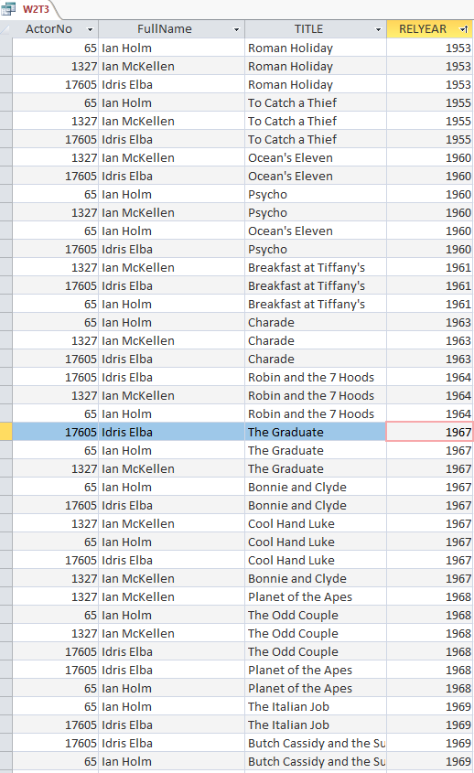

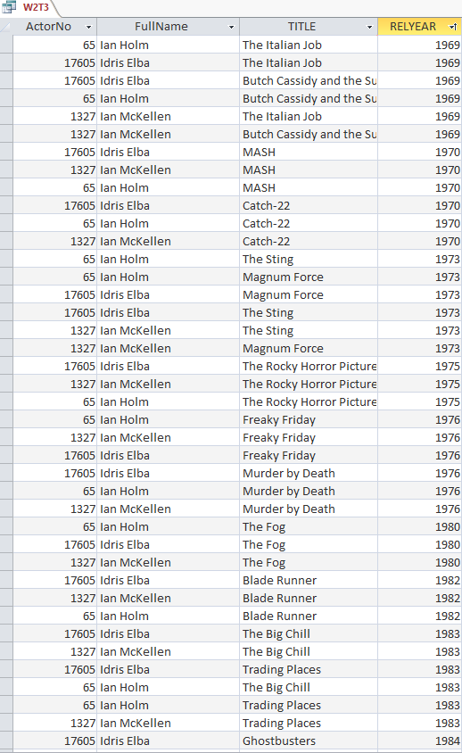

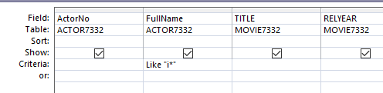

## Task 4

Paste your screen captures for this task here.

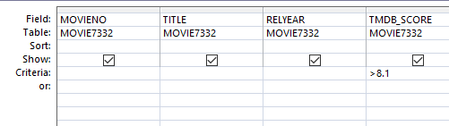

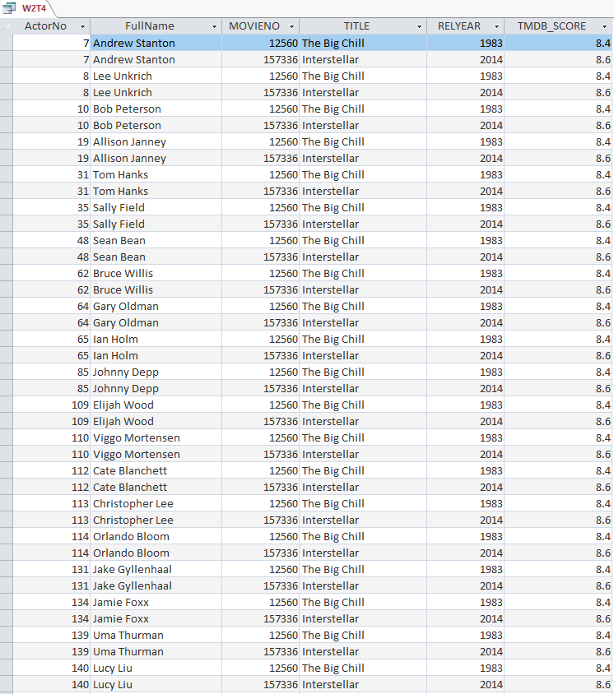

## Task 5

Paste your screen captures for this task here.

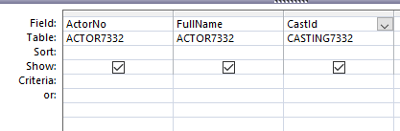

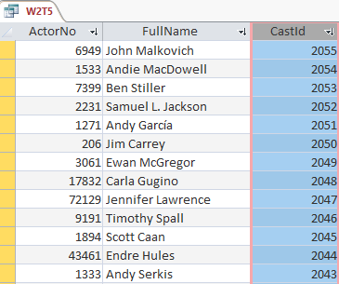

## Task 6

Paste your screen captures for this task here.

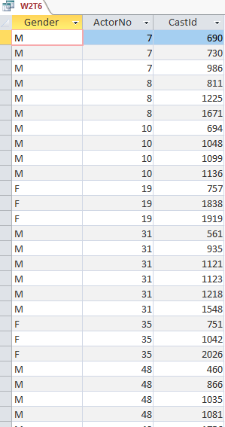

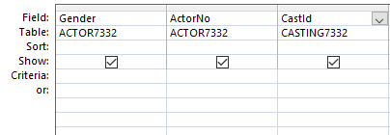

## Task 7

Paste your screen captures for this task here.

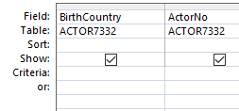

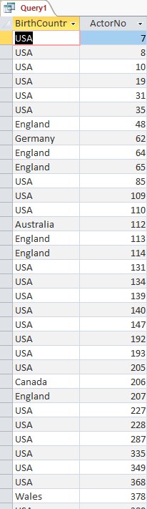

## Task 8

Paste your screen captures for this task here.

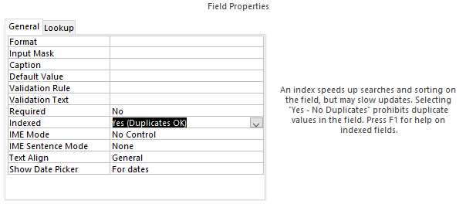

## Task 9

Paste your screen captures for this task here.

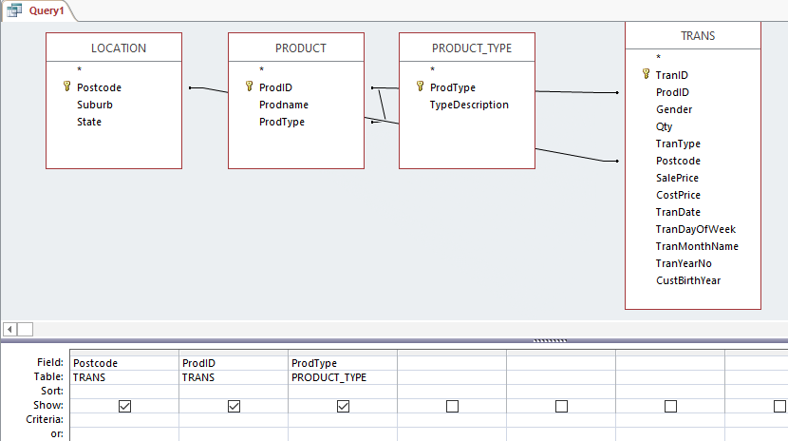

## Task 10

Paste your screen captures for this task here.

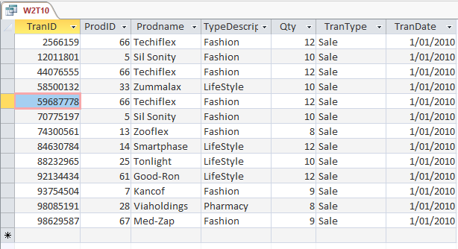

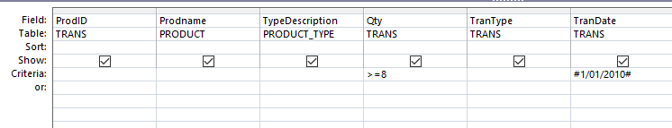

## Task 11

Paste your screen captures for this task here.

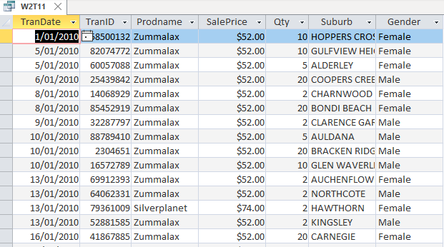

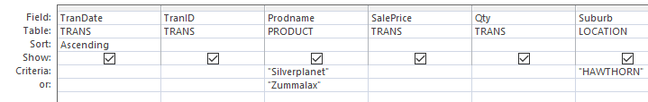

## Task 12

Paste your screen captures for this task here.

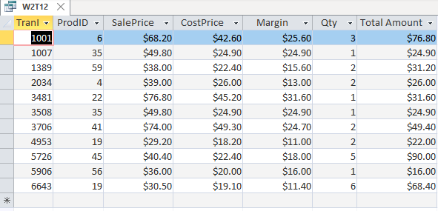

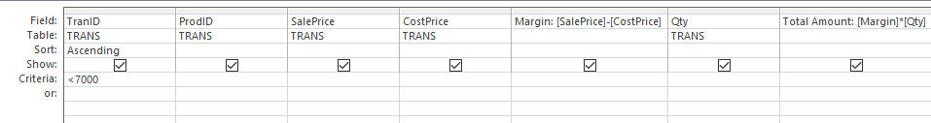

## Task 13

Paste your screen captures for this task here.

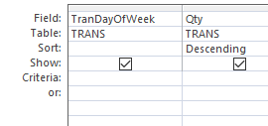

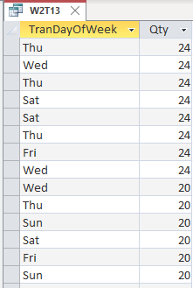

## Task 14

Paste your screen captures for this task here.

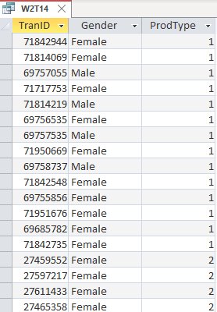

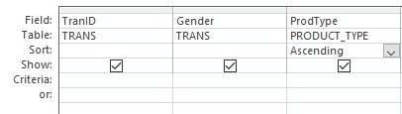

## Task 15

Paste your screen captures for this task here.

